# Continuity

A function is **continuous at a number $a$**  if:

1. $f\left(a\right)$ exists.
2. $\lim_{x→a}f\left(x\right)$ exists.
3. .

# File:Function-1 x.svgDiscontinuity

A function is **discontinuous at $a$**  if it is **not continuous at $a$** . You can also phrase this as “the function has a **discontinuity at $a$** .”

At $x=0$, is the graph to the right continuous?

To the right is an example of **infinite discontinuity** because there’s an asymptote that comes from either positive or negative infinity.

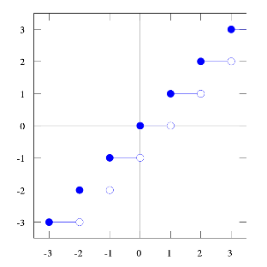

The floor function is to the left. Every time $x$ reaches a new integer, $y$“jumps” to a new value without any continuity in-between. This is called **jump continuity**.

Photo credit. © Omegatron.



To the right, notice that at $x_{0}$ there’s an open circle (○) and a closed circle (●). This means that the open circle is $\lim_{x→x_{0}}{f\left(x\right)}$, but the blue circle is the actual value of the function, $f\left(x_{0}\right)$.

Since $\lim_{x→x_{0}}{f\left(x\right)}≠f\left(x_{0}\right)$, the function to the right is discontinuous at $x_{0}$. This is a **removable discontinuity**.

# Continuous from the Side

A function is **continuous from the** **right** if: $\lim_{x→a^{+}}{f\left(x\right)}=f\left(a\right)$.

A function is **continuous from the** **left** if: $\lim_{x→a^{-}}{f\left(x\right)}=f\left(a\right)$.

# Continuous on an Interval

A function is **continuous on an interval** if the function is continuous at each number in the interval.

If functions $f$ and $g$ are continuous at $a$, and $c$ is a constant, then the following are also continuous at $a$:

$f+g$

$f-g$

$cf$

$fg$

$\frac{f}{g} if g\left(a\right)≠0$

**Polynomials** (e.g., $8x^{5}+3x^{4}+2x^{2}-7x+1$) are **continuous on all real numbers** ($R$), because polynomials don’t have holes anywhere across all the real numbers. Thus, polynomials are continuous on the interval of all real numbers, or $(-R,R)$.

**Rational functions** (fractions of polynomials), **root functions** (square root, cube root, etc.), and **trigonometric functions** are **continuous across their entire domain**. They do not all have the same domain, though.

# Continuity with Composite Functions

If $f$ is continuous at $b$ and $\lim_{x→a}g\left(x\right)=b$, then, substituting for $b$, $\lim_{x→a}f\left(g\left(x\right)\right)=f\left(b\right)$. This is true because, for $f$ to be continuous at $b$, rule three says:

1. $\lim_{x→a}{f\left(x\right)}=f\left(a\right)$.

If $g$ is continuous at $a$ and $f$ is continuous at $g(a)$, then the composite function $f∘g$ is continuous at $a$.

# The Intermediate Value Theorem

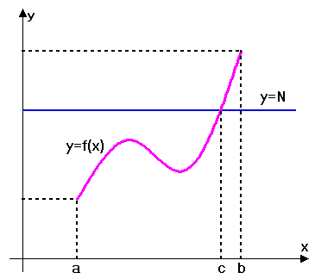Suppose $f$ is continuous on $[a,b]$. For any number $N$ between $f(a)$ and $f(b)$, there is a number c such that $f(c)=N$. See the graph to the right for illustration.

Image credit © http://imgarcade.com